Reviewing tip frequency after rideshare rides

Andrew Fox

Colorado State University – Global Campus

MIS581: Fraud Data Analysis

Dr. Steve Chung

**Reviewing tip frequency after rideshare rides**

**Abstract**

Rideshare apps and other gig economy work have grown substantially worldwide over the past 10 years, accelerated by the pandemic and “great resignation” starting in 2020 and 2021 respectively. Uber and Lyft were two of the first companies to push for this disruptive model, with companies like DoorDash, Instacart, Fiverr, AirBNB, WeWork, TaskRabbit, Turo springing up to fill market gaps. Even companies like Ebay, Etsy and Amazon Marketplace are pushing the idea of freelance work, selling goods, services and labor independently through a platform instead of through a traditional business model.

This has not come without pushback. Taxi drivers in multiple cities have protested or gone on strike over the undercutting done by these apps. Regulators have tangled with many of these listed companies over deceptive business and labor practices. Employees have complained about the pay provided by these companies, from misleading marketing about earning to potential to straight up lying about compensation and stealing tips. This is especially a problem in America due to the unique tipping culture present in the states. Many gig economy workers, as well as traditional hospitality workers rely on tips as a substantial portion of their earnings.

This paper explores the reality of tipping among rideshare drivers. While there is a difference in tip frequency based on various factors, the only factor that matters in practice is the total fare. This paper proposes that while the predictive value of those other factors is not worth considering while a rideshare driver is attempting to increase earnings.

**Introduction**

Over the past 15 years, gig-based employment has grown explosively in the United States. Companies like Doordash, Instacart, Lyft and Uber have allowed individuals to work as “independent contractors” and disrupted the traditional employment market[1]. Websites like Fiverr and TaskRabbit enabled technical and general labor workers to find freelance opportunities that would have been difficult or impossible before the internet boom. However, these changes are not without consequences. Many gig economy platforms have come under fire for unethical and illegal practices Some examples include intentional law breaking, obstruction of justice, and constant legal battles to stall classifying drivers as employees (Stylianou et al, 2022). And many of these markets that the gig economy has penetrated are traditionally tip-based work, such as food delivery and taxi/transportation drivers.

This has drawn criticism that overlaps with tipping culture. In America, tipping culture has grown greatly since the beginning of the COVID-19 pandemic. There are many criticisms of the American reliance on tips to pay hospitality workers, such as waiters, bartenders and baristas. Many of these workers are allowed to be paid the “sub-minimum wage”. As long as their tips add up to minimum wage, in most parts of the United States employers are not required to pay their employees more than $2.13 an hour (US Department of Labor [DOL], 2025). Tipping has come under increasing scrutiny as consumers learn how the system is used to justify these sub-minimum wages. Uber and Lyft do not fall into this category, as they pay drivers well above the minimum wage, but tipping is still part of driver's compensation. Both Lyft and Uber have options to tip drivers built into their platforms.

**Objectives**

The purpose of this paper is to review the tipping behavior within rideshare. This paper will review data submitted by the Transportation Network Providers [TNP] (Uber, Lyft and any other companies that match riders and drivers to provide on demand general transportation) to the City of Chicago (2025). The paper will review existing literature relating to tipping on rideshare apps, notably Chandar et al (2019) which provides the framework for study of the current dataset.

The aim of this research is to validate or reject some of the conclusions of Chandar et al and to create a predictive model for the likelihood of a tip. This research will not address the magnitude of tips, only their frequency.

**Overview of Study**

The benefits of expanding the knowledge of rideshare tipping patters are numerous. Rideshare drivers operate at a significant information disparity compared to the companies. Just reviewing the TNP data, there is a significant amount of data withheld from that dataset. As reported in the column descriptions, any location data not in the city of Chicago is removed from the dataset. This is due to the TNP not reporting data points outside the scope of the city ordinance that requires these disclosures. Rideshare drivers are constantly contending with this information inequality between themselves and the TNP. The business practice of treating drivers as independent contractors expands this disparity by making it more difficult for drivers to share information among each other.

Drivers can use the information gained from any predictive model to assist in ride selection. While drivers would not be able to run each offer through any model prior to accepting a ride, a model would allow for drivers to develop a heuristic rule to maximize tip earnings and understand their income patterns. This also allows for a better understanding of American tipping culture, which has come under criticism over the past decade or so. And while up to 79% of Americans tend to tip in restaurants, about 40% leave a tip on a TNP ride, with about 16% of rides having a tip (Chen et al, 2023, 83. Chandar et al, 2019). Chen et al also show evidence that suggests tips are increased when the rider is asked to tip before they are asked to rate the driver. While their data is more than 5 years old (nearly 4 years older than the data included in this research), it does show that the original tipping system deployed by Uber – having the customer rate and tip at the same time – could be less effective than soliciting tips before asking for a rating.

Ultimately, the largest benefit from additional research in the field is the increased understanding of tipping culture, both on TNP and in general. Additional research on tipping has been done, and many social and economic changes have happened since the original data was gathered in 2017, with the largest being the COVID-19 pandemic and associated recession. The economic impacts were severe, with unemployment rising to a record 14.7% in April 2020 (Bureau of Labor Statistics [BLS], 2020). Jobs were lost much faster than individuals were able to find employment after the initial shock, and society will not return to all pre-pandemic norms. Additionally, there is a perception that inflation will increase again, and consumer sentiment is “… now comparable to the peak readings from the post-pandemic inflationary episode” (Hsu, 2025a). While the three-month period referenced by Hsu exceeds the timeframe of the data gathered by Chicago, these sentiments show that consumers are concerned with inflation, and the update from January 2025 shows that sentiments have been declining for much of timeframe covered by the dataset.

**Research Questions and Hypotheses**

There are a few different hypotheses that will be tested during this research project, as it attempts to answer multiple questions.

**Question A:** The tip frequency remains near 16%

As Chandar et al (2019) found, the tip frequency on Uber was around 16% in 2017. While this is a good starting point for the research, social behaviors can change fairly quickly. The eight years since their data was collected is a long time in technology and technology-adjacent fields. This is the baseline question that needs to be addressed as part of this research. Considering both datasets are samples, an identical frequency is not expected; however, the frequencies should not be significantly different.

H0a: The tip frequency is at or around 16%.

H1a: The tip frequency is significantly different than 16%.

**Question B:** A statistical model can be created to predict tip likelihood.

There are a variety of factors that can be reviewed based on the Chicago dataset, some of which could have predictive power. The factors that will be fed into the predictive model are listed above, but they condense to four different factors: total fare, trip duration, day of week and time of day. Trip duration in the final model will use whichever factor has the stronger relationship with tip frequency, as distance and time will have high levels of covariance.

Questions C through G relate to establishing relationships between each individual variable and tip frequency, and are stepping stones along the way to creating a full predictive model. Trip day of week and time of day had to be reduced to simpler binary variables since the day of week and hour are ordinal variables, not numerical variables. Since a predictive model would treat them as numerical, they were turned into binary variables. The day of week variable is based around how Uber, and to a lesser extent Lyft, treat the days of the week. More points are available toward their reward programs on Fridays, Saturdays and Sundays than Mondays through Thursdays. The time-of-day classification is from the Britannica Dictionary (2025).

H0b: There is no relationship between day of week and tip frequency.

H1b: There is a relationship between day of week and tip frequency.

H0c: There is no relationship between time of day and tip frequency.

H1c: There is a relationship between time of day and tip frequency.

H0d: There is no relationship between trip distance and tip frequency.

H1d: There is a relationship between trip distance and tip frequency.

H0e: There is no relationship between trip duration and tip frequency.

H1e: There is a relationship between trip duration and tip frequency.

H0f: There is no relationship between total fare and tip frequency.

H1f: There is a relationship between total fare and tip frequency.

H0g: A predictive model cannot be created based on the variables provided.

H1g: A predictive model can be created to show predict the likelihood of tips based on one or more of these factors: day of week, time of day, distance, duration and fare.

**Literature Review**

Research regarding tipping behavior is somewhat sparse, at least in part due to a lack of interest outside the United States. While historians are not necessarily able to pin down the origins of tipping, it is believed to come from Europe where the practice was used to reward servants for exceptional performance. Wealthy Americans saw this practice in the 1800s and brought it stateside, then the Fair Labor Standards act of 1938 codified the subminimum wage (Greenspan, 2019). As businesses understood the opportunity to use tipping as a way to reduce payroll - by offloading the cost onto the consumer more directly - they encouraged the practice. With less interest outside the US Market, there is less demand for the research on a global scale.

But there is still some research to review. As discussed, Chandar et al (2019) discusses not only tipping behavior, but specifically tipping behavior in ride sharing. There are many aspects of their research that this paper is unable to review, but it still forms the foundation of this undertaking. Initial work on this research uncovered that the tip frequency might not align with the conclusions of Chandar (see Results). Because of this, a significant portion of the literature review and research is devoted to understanding why H0a might be nullified.

One thing that is not reviewed in Chandar but is reviewed in a later study is the timing of tipping. Chen et al (2023) reviewed the impact of providing feedback on employee performance prior to being asked to provide a tip. According to their research, tip frequency is reduced when the customer is asked to provide a tip if they have separately rated their driver on Uber and Lyft.[2] This indicates that some portion of the population still feel the drive to tip as a reward for a job well done, not an obligation to contribute to driver compensation.

This is important to consider given changes over the past 10 years. A Pew Research study from 2023 shows that Americans feel tipping has become more expected since 2018. Additionally, some people are growing unhappy with “a growing expectation to subsidize workers’ pay” (McCorvey, 2023). This sentiment is backed up by an example in the story where more than a third of a barista’s income came from tips. However, the percentage of income that comes from tips varies wildly. The author has driven for Uber, Lyft and DoorDash. When driving for Uber, the last completed week (April 6 - 13, 2025) was 10% ($80.50 of $798.11). But during the final week driving for DoorDash (December 2-8, 2024), 56% of the compensation was from tips ($438.77 of $782.34)[3]. Another supporting point for the feeling described in that article is a quote from payment processor Toast, whose spokesperson stated, “Tipping is still slightly up compared to the time right before the pandemic in 2019”.

Perhaps the most interesting tidbit uncovered in this review relates to emojis. A presentation at the American Marketing Association’s 2023 Winter Academic Conference (Lefebvre et al, 2023) shows research that indicates the use of emojis in the tip interface could increase the tip percentage (not frequency). As rideshare drivers have no ability to change the tip interface, that specific point has no relevance to the rideshare worker. However, the overall discussion by Lefebvre has two points that relate back to other literature. First, it highlights the conclusions from Chen that discusses how the presentation of tip options changes tip behaviors. This is also supported by a researcher Diedre Popovich, who mentions that people do not want to use “cognitive resources” and go on autopilot to increase tips from customers (McCorvey, 2023). Second, it goes back to a point raised in Chandar about the potential of outgoing or extroverted drivers seeing higher tips. While they were unable to make those conclusions due to the lack of data, previous research had shown extraversion to be correlated with higher tips in the food service industry. Chandar posits that since those traits also correlate with higher driver ratings - and higher driver ratings have increased tip frequency - that these same traits likely have a substantial covariance. The underlying theory of Lefebvre is that the emojis are driving positive emotions, similarly to how a positive interaction with a server increases positive emotions that drive tips in restaurants.

Overall, the literature is underdeveloped around tipping and especially as it relates to rideshare drivers. Tangentially related articles and non-academic researchers lend a clearer picture to the questions raised, but the answers are still unclear.

**Research Design**

The dataset being used is from the Chicago Transportation Network, and is a collection of all rides reported to the city of Chicago in 2023 and 2024. This is used as a sample for rides in the entire United States. Many of the columns are dropped using the CTN’s query tool, as a full set download would not load into Excel or R for preparation. Because of this, only the following fields were downloaded: Trip.Start.Timestamp, Trip.End.Timestamp, Trip.Seconds, Trip.Miles, Fare, Tip. This allows for the main variables to be looked at: day of week, time of day, duration (in distance and time) and total fare.

In order to prepare the data, the data must be cleansed for both errors and to remove outliers. For example, the max value for a fare is over $2000 dollars and the longest trip was 526.7 miles. These are such extreme outliers they should be removed for computational efficiency as well as making sure the model is not skewed by their extreme values. This also allows for the histograms to be readable, since with the skewed values tailing so far to the right the histogram is practically illegible. There are also about 500,000 NA values that need to be removed (likely cancelled rides).

The data will be prepared and analyzed using R (The R Foundation, n.d.). Packages including Tidyverse and scales will be used to prepare and present the data. Logistic regression will be used to determine the impact of variables on the likelihood of a tip. Multiple regression and decision trees will be used to determine if there is a model that can predict the likelihood of a tip with multiple variables considered.

The following variables will be used in the model and analysis:

|  |  |  |  |
| --- | --- | --- | --- |
| Variable Name | Description | Type | Created or downloaded |
| TipYesNo | A binary yes/no value that will show whether a tip was left on the ride. The dependent variable in all models. | Binary | Created |
| Fare | The total amount charged to the customer by the rideshare service. Does not include the tip. | Numerical | Downloaded |
| Trip.Seconds | The duration of the trip in seconds. | Numerical | Downloaded |
| Trip.Miles | The length of the trip in miles, to the tenth of a miles. | Numerical | Downloaded |
| IsWeekday | Whether the day of the trip is a Monday through Thursday. | Binary | Created |
| IsWeekend | Whether the day of the trip is a Friday through Sunday. | Binary | Created |
| IsMorning | The ride started between 5:00 AM and 12:00 PM. | Binary | Created |
| IsAfternoon | The ride started between 12:00 PM and 5:00 PM | Binary | Created |
| IsEvening | Ride takes place between 5:00 PM and 9:00 PM. | Binary | Created |
| IsNight | Ride takes place between 9:00 PM and 5:00 AM. | Binary | Created |

**Methods**

The primary method used to test the relationships will be logistic regression. Logistic regression attempts to show the relationship between two or more variables where the dependent variable is a binary outcome, such as yes/no (Sperandei, 2014). Another technique used is Classification and Regression Trees, or CART (Michini & Zhou, 2025). This is used to attempt to determine the likelihood of a tip based on multiple variables. While logistic regression can be used for this as well, the auto-pruning nature of a CART allows for reviewing where relationships might change based on variables. For example, if the relationship between tip frequency and distance changes based on total fare, that is easier to evaluate in a CART than in a traditional regression model. Finally, a binomial test is used to determine the likelihood that the tip frequency found is significantly different than the previously reported percentage by Chandar et al (2019).

**Ethical considerations**

There are no ethical considerations within the dataset and research. Due to the amount of data scrubbing by Uber, Lyft and the city of Chicago, there are few identifying markers available. The coordinate data can be used to locate pickup and drop-off points. However, those variables were dropped from the dataset before downloading to reduce the size of the dataset in memory.

**Results**

The first test is to examine the tip frequency in the sample. After removing the invalid records, we are left with approximately 170 million records, of which there are about 43 million tips[4]. This results in a tip frequency of 0.2557044 (25.57%), with a 95% CI range of 0.2556389 and 0.2557699. The tip frequency in this sample is significantly higher than the tip frequency observed by Chandar (2019).

Next up is testing the likelihood of tips based on the day of the week. Because this is two binary variables where one is positive the other is negative there is no need for multiple variables in the regression since IsWeekDay and IsWeekEnd have 100% covariance. The p-value (Pr(>|z|)) is <2e-16, meaning there is a significant relationship the day of the week and the likelihood of a tip. Surprisingly, the relationship suggests there is a negative correlation between IsWeekEnd and IsTipped. Conventional wisdom would suggest that there are more tips from people taking trips to social events since those riders would have more disposable income to afford a tip. The confusion matrix also shows that there is a significant number of False Negatives, meaning that the day of week is not a primary driver. While there is a relationship between day of week and the tip frequency, it is not stronger than other predictors.

The third test is for the time-of-day prediction. This time there are four different variables for each stage of the day as explained above. In this case, multiple models will be created to find the most reliable model, since the model can only hold three of the variables at once. The model with isMorning, isAfternoon and isEvening will be used as all coefficients are positive. With the p-value being <2e-16, there is a significant relationship between the time of day and tip frequency with night having the lowest relationship to tip frequency. The confusion matrix shows there was still significant variance not accounted for by time of day but much closer than the day of week.

Duration also has significance, as does distance. This is not a surprise as distance and duration are very highly correlated. Fare also has a fairly significant relationship with tip frequency. However, this will also have large covariance with duration and distance, although not as much as the covariance between duration and distance.

For the final predictive model, a decision tree is more appropriate than linear regression. Decision trees evaluate the dataset and attempt to group the data into few, meaningful groups, similar to k-nearest neighbors. The goal is to correctly group the results into the highest number of leaves (clusters), while keeping the tree as simple as possible (Michini & Zhou, 2025).

The tree yields expected results. The biggest driver of tip frequency is the total fare, with fares under $8.80 having the lowest tip frequency of 21%. Tips above $34.00 have the highest tip frequency of 41%. The only other differentiating factor is the distance traveled. Between $8.80 and $23.99 the distance was a significant enough factor to differentiate, with longer trips having a slightly higher tip frequency (28% vs 22%).

**Discussion and Conclusion**

The most surprising difference is the tip frequency being so much higher than in Chandar. This can be explained by shifting social patterns since the original study took place. With Americans feeling they are expected to tip more, and more than half of them at least often tipping on rideshare apps, it is understandable that the tip frequency has risen by more than 50%. Further research could be done to reconcile the difference between the observed tip frequency (25.57%) and the percentage of Americans who claim to tip. One possible explanation is that those who tip frequently utilize rideshare less frequently. This theory would reconcile the difference between the observed data and the research done separately by Pew (DeSilver & Lippert, 2023).

Unfortunately, this is one area that the current study cannot review. Due to the removal of nearly all identifiable information from the dataset before publication, there is no way to verify the patterns of individual riders. Nevertheless, Chandar (2019) still provides some valuable insight. While this paper finds their tip frequency is not significant, that does not invalidate their other observations. In fact, Chandar does suggest that the most frequent tippers are the minority, with only 1% of riders tipping on every trip. Some other observations that Chandar made which cannot be reviewed in this research include:

* Driver and rider rating have a significant impact on tip frequency.
* Rider characteristics are much more influential on tip frequency than driver characteristics. This is consistent with extant literature on charity donations.
* Gender of the rider and driver has a significant impact on tip frequency.
* Tips are more frequent on business and airport trips
* Rough driving characteristics, such as hard braking, quick acceleration and speeding are negatively correlated with tips.
* Riders tip less frequently the more rides they take, and drivers are tipped less frequently as they complete more rides.

Overall, the decision tree yields a solid insight, but nothing novel. The higher the fare, the more likely a rider is to tip; they are also more likely to tip on longer rides but this does not outweigh the fare total. Notably, day of week and time of day are never close to the significance of the total fare and distance. The decision tree considers the fare with an importance of 52, the distance an importance 29 and the duration an importance 19. While this tree does confirm the original hypothesis that tip likelihood can be predicted to an extent, the research shows that drivers should not focus on attempting to increase their tip frequency. With roughly 10% of total income coming from tips, drivers are better off trying to take efficient fares (base pay is high for the time required) instead of trying to increase tips. Especially since Chandar (2019) found that tip amount increases concavely with fare amount. Specifically, a 10% increase in the fare only increased the tip amount by 2.5%. Chasing larger fares would not be efficient compared to completing many fares. This still increases the likelihood of tips while maintaining an efficient workflow.

References

Bureau of Labor Statistics. (2020, May 8). *The Employment Situation – April 2020.* https://fraser.stlouisfed.org/title/employment-situation-144/april-2020-589619

Chandar, B., Gneezy, U., List, J. A., & Muir, I. (2019, Oct). The drivers of social preferences: Evidence from a nationwide tipping field experiment. *National Burean of Economic Research.* <https://www.nber.org/papers/w26380>

Chen, J., Xu, A. J., Rodas, M. A., & Liu, X. (2023, Jan). Order matters: Rating service professionals first reduces tipping amount. *Journal of Marketing. 87,* 1 (81-96). https://doi.org/10.1177/00222429221098698

City of Chicago. (2025, Feb 27). Transportation Network Providers – Trips (2023-2024). *Chicago Data Portal.* <https://data.cityofchicago.org/Transportation/Transportation-Network-Providers-Trips-2023-2024-/n26f-ihde/about_data>

deSilver, D., & Lippert, J. (2023, Nov 9). Tipping culture in America - Public sees a changed landscape. *Pew Research Center.* https://www.pewresearch.org/2023/11/09/tipping-culture-in-america-public-sees-a-changed-landscape/

Encyclopædia Britannica, Inc. (2025). *Parts of the Day: Early morning, late morning, etc.* Retrieved April 13, 2025. <https://www.britannica.com/dictionary/eb/qa/parts-of-the-day-early-morning-late-morning-etc>

Greenspan, R. E. (2019, Aug 20). ‘It’s the legacy of slavery’: Here’s the troubling history behind tipping practices in the U. S. *Time Magazine.* <https://time.com/5404475/history-tipping-american-restaurants-civil-war/>

Hsu, J. (2025, Jan 24). January 2024 survey results. *University of Michigan surveys of Consumers.* <https://data.sca.isr.umich.edu/fetchdoc.php?docid=77939>

Hsu, J. (2025, Mar 28). March 2025 update: Current vs pre-pandemic long-run inflation expectations. *University of Michigan survey of consumers.* <https://data.sca.isr.umich.edu/fetchdoc.php?docid=78367>

Lefebvre, S., Boman, L., & Orlowski, M. (2023). Wait til you about the impact on tipping [sic]. *AMA Winter Academic Conference Proceedings. 34.* (1220-2). <https://csuglobal.idm.oclc.org/login?url=https://search.ebscohost.com/login.aspx?direct=true&AuthType=ip,uid&db=bth&AN=161908857&site=eds-live>

McCorvey, J. J., (2023, Feb 4). Americans are tipping more often, even if they don’t want to. *NBC News.* https://www.nbcnews.com/business/consumer/tipping-etiquette-restaurants-gratuity-tipflation-rcna67316

Michini, C., & Zhou, Z. (2025, winter). A polyhedral study of multivariate decision trees. *INFORMS Journal on Optimization. 7*(1), 61-82. <https://doi.org/10.1287/ijoo.2023.0017>

Sperandei, S. (2014, Feb 15). Understanding logistic regression analysis. *Biochem Med (Zagreb). 24*(1), 12-18. https://pmc.ncbi.nlm.nih.gov/articles/PMC3936971/

Stylianou, N., Dale, B., & Dahlgreen, W. (2022, Jul 11). Uber files: Greyballing, kill switches, lobbying – Uber’s dark tricks revealed. *BBC Panorama.* <https://www.bbc.co.uk/news/resources/idt-f2971465-73d2-4932-a889-5c63778e273d>

*The R Foundation.* (n.d.). R: The R project for statistical computing. Retrieved April 6, 2025. https://www.r-project.org/

United States Department of Labor. (2025, Jan 1). *Minimum Wage for Tipped Employees.* https://www.dol.gov/agencies/whd/state/minimum-wage/tipped

Appendix A:

Figure 1

Screenshot of the default tip menu in the Lyft app, captured by the author.

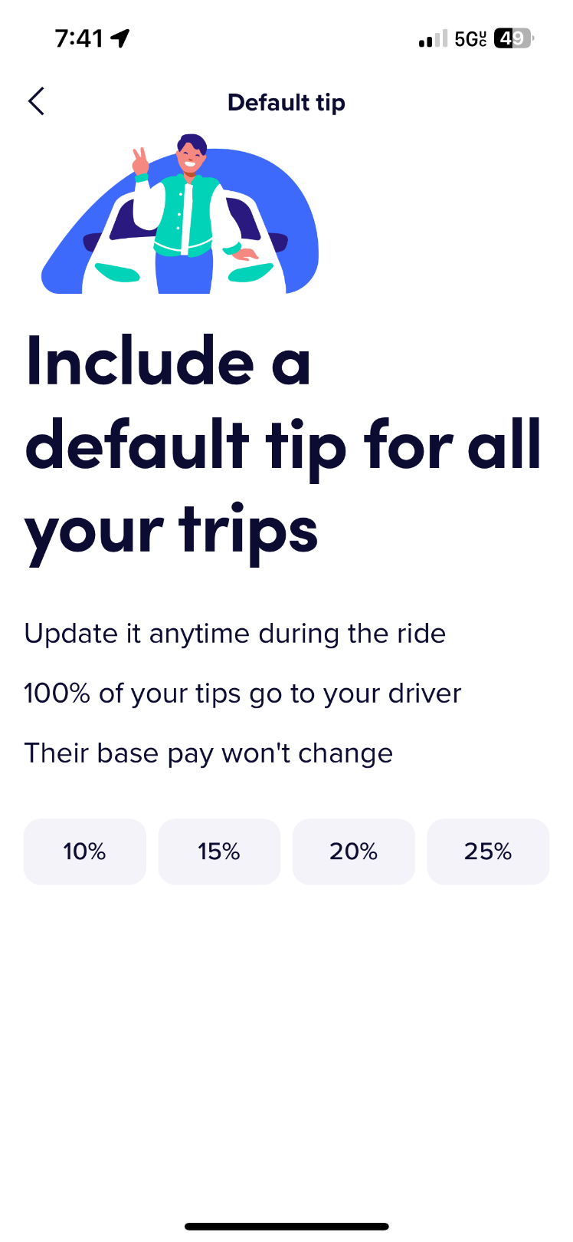



Appendix B: Testing Visualizations

Figure 2

Day of Week Histogram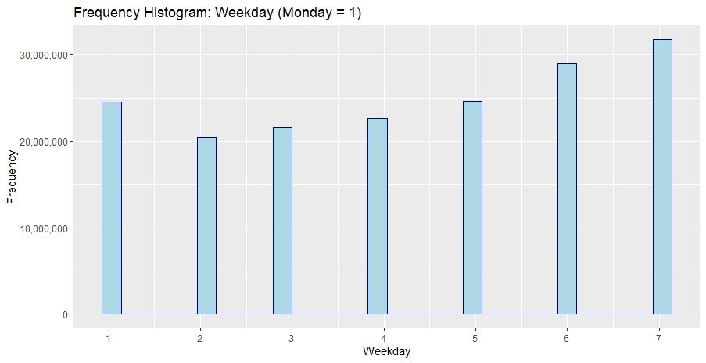

Figure 3

Distance Histogram

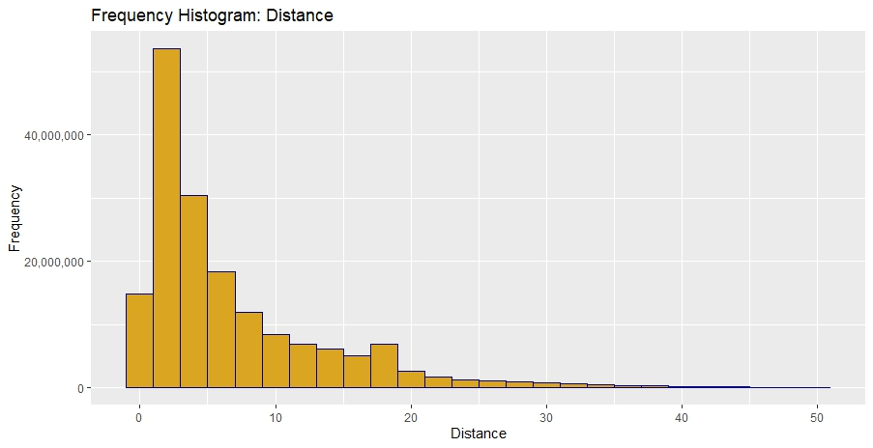

Note: Distance is in miles

Figure 4

Duration Histogram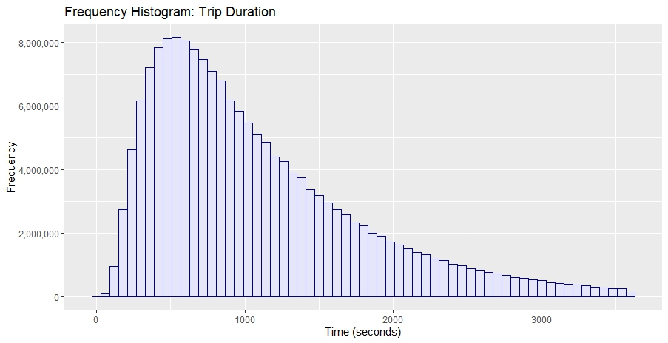

Figure 5

Fare Histogram

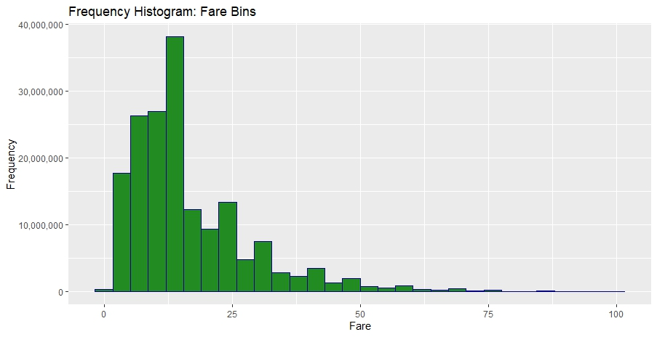

Figure 6

Day of Week Regression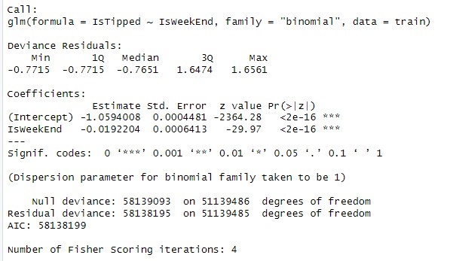

Figure 7

Day of Week Confusion Matrix

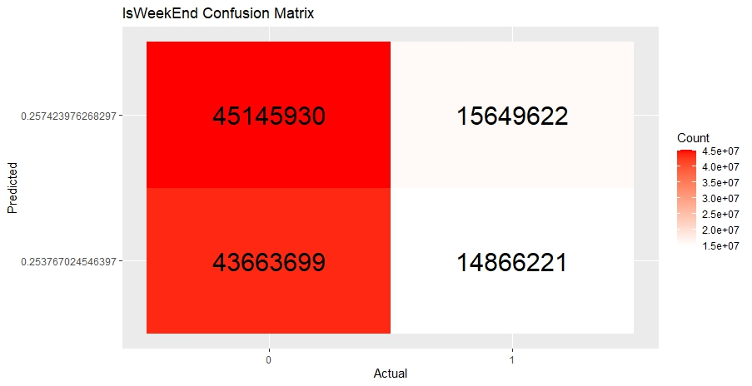

Figure 8

Time of Day Regression

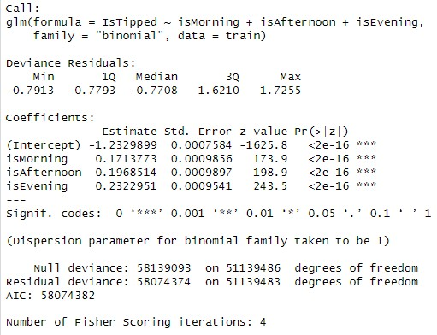

Figure 9

Time of Day Confusion Matrix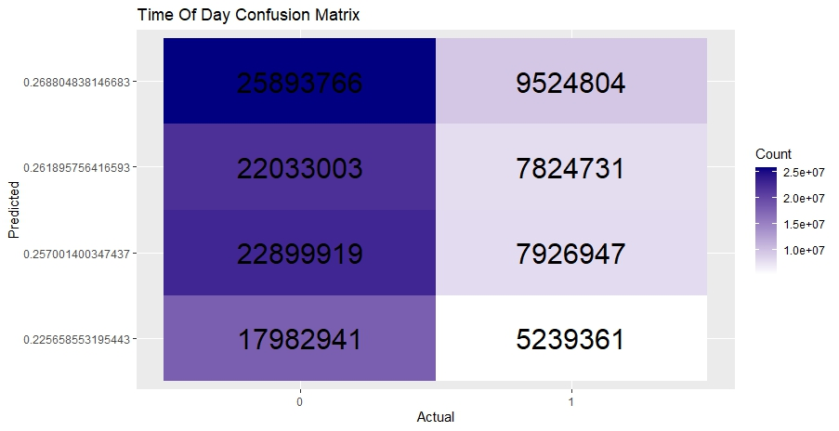

Figure 10

Duration Regression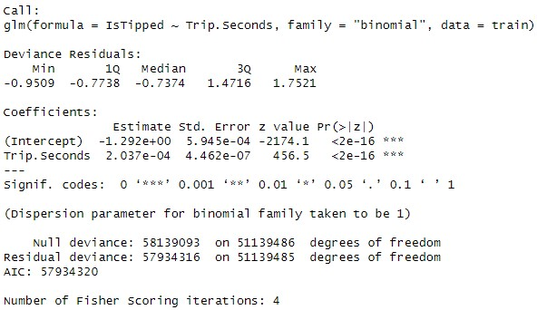

Figure 11

Distance Regression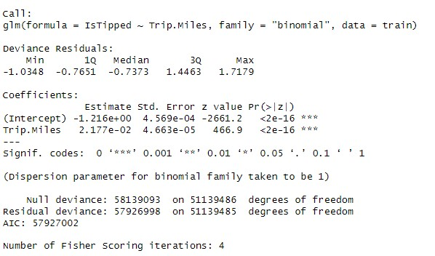

Figure 12

Fare Regression

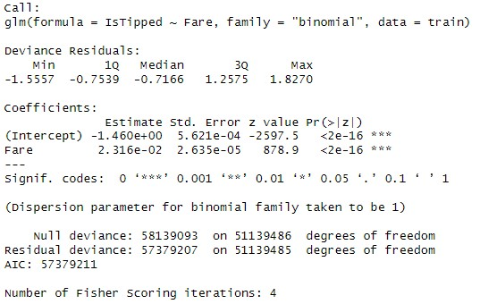

Figure 13

Tip Frequency Decision Tree

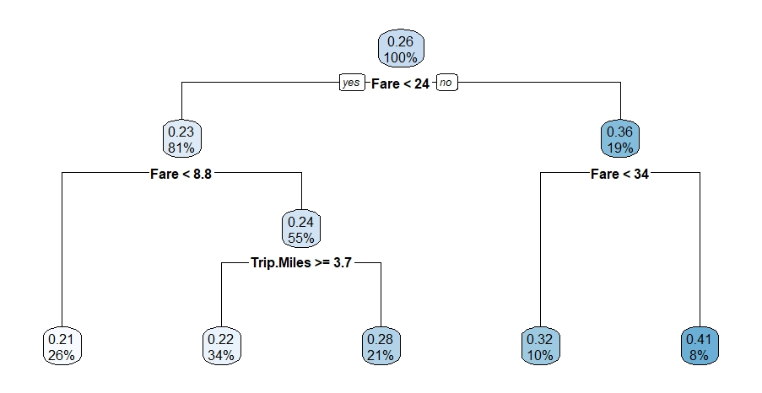

Figure 14

Regression Tree Summary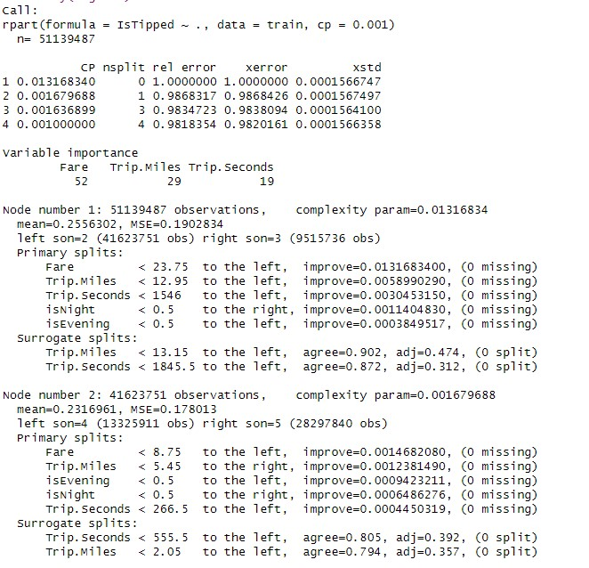

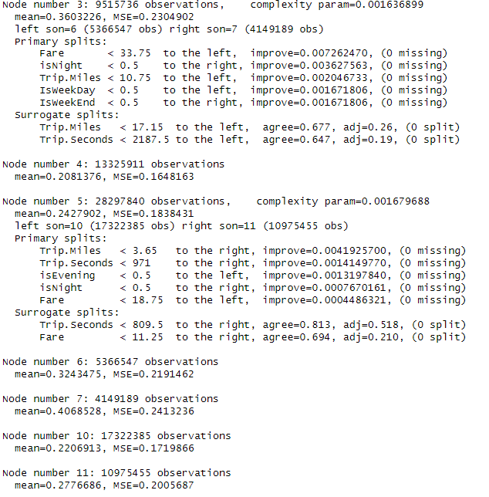

Figure 15

Regression Tree Visualization

1. The author is currently a rideshare driver using both the Uber and Lyft platforms, but not in Chicago and his rides will not be included in the data. The author also previously drove for the DoorDash platform.
2. Notably for this paper, Uber has stopped requesting that the customer rate the employee before prompting for a tip (personal correspondence, April 20, 2025).
3. For reasons beyond the scope of this paper, the DoorDash numbers should not be directly compared to Uber income and the barista’s income since there is a self-selection bias in the data. It is simply provided to illustrate the percentage tipped employees can rely on tips to achieve a baseline income.
4. 170464959 records, 43588639 of those have a tip.